Automotive Safety using IOT-Integrated
Miniaturized Ultrasonic Radar

A Design Thinking Project

Abstract:

The project titled "Automotive Safety using IoT-Integrated Miniaturized Ultrasonic Radar" aims to revolutionize automotive safety by leveraging the power of IoT and miniature ultrasonic radar technology. The project focuses on addressing the critical issue of blind spots in vehicles, which often lead to accidents on the roads. By integrating IoT capabilities with miniature ultrasonic radar, the project aims to provide real-time information about the vehicle's surroundings and enhance collision avoidance systems. The report presents a comprehensive analysis of the problem statement, including user needs, pain points, and the customer service experience. Through the application of design thinking principles and ideation methods such as SCAMPER and Modify, innovative solutions are generated to mitigate blind spots and enhance road safety. The report also details the development of a prototype circuit model and its evaluation in terms of desirability, feasibility, and viability. The conclusions highlight the significance of miniature ultrasonic radar in mitigating blind spot-related risks and improving automotive safety. The project offers valuable insights and future scope for advancements in the field, paving the way for safer and more efficient vehicles on the roads.

TABLE OF CONTENTS
Details of Contents |  | Page no.
Abstract |  | Ii
Table of Contents |  | Iii
List of Figures |  | iv
Chapter 1: Introduction to the Problem |  | 1
1.1 Objective
1.2 Outline
1.3 Motivation
1.4 Scope of the Project
Chapter 2: Discover and Define |  | 2-4
2.1 Empathy Interview
2.2 Persona
2.3 User Needs
- 2.3.1 Primary needs
- 2.3.2 Secondary Needs
- 2.3.3 Latent Needs
Chapter 3: Customer service experience |  | 5-6
3.1 Service experience cycle
3.2 Pain point address
3.3 Real-Life Scenarios and Case Studies

Chapter 4: Ideation |  | 7-8
4.1 Ideation Tools
- 4.1.1 Modify
- 4.1.2 Combine
4.2 Outcome of Ideation Phase
Chapter 5: Prototype model |  | 9-12
5.1 Prototype Circuit Model
5.2 Task Flow
5.3 Evaluation of Prototype Based on Desirability, Feasibility& Viability
Chapter 6: Conclusions and Future Scope |  | 13-14
6.1 Conclusions
6.2 Future Scope
References | 15
Appendix A: User Surveys |  | 15-17
A.1 Questionnaire for Users
A.2 Text Transcripts of User Responses

LIST OF FIGURES
Details of Contents | Page #
Figure 5.1.1: Model Circuit | 10
Figure 5.1.2: Prototype | 10
Figure 5.1.3: Statistical Analysis of Sensor | 11
Figure 5.2.1: Task Flow | 12
Figure 6.2.1: V2V Communication | 14
Figure 6.2.2: Scope of Sensors | 14
Figure 6.2.3: Sensors with LIDAR | 14
Figure A.2.1: User Response - 1 | 16
Figure A.2.2: User Response - 2 | 16
Figure A.2.3: User Response - 3 | 16
Figure A.2.4: User Response - 4 | 17
Figure A.2.5: User Response - 5 | 17
Figure A.2.6: User Response - 6 | 17

CHAPTER 1
INTRODUCTION TO THE PROBLEM

  - Objective
The objective of the project is to identify and address the problem of blind spots in vehicles and their impact on road safety. Blind spots refer to areas around a vehicle that are not directly visible to the driver, posing a significant risk as they can obstruct the view of other vehicles, pedestrians, or objects on the road. These blind spots often lead to accidents and collisions, making it crucial to find effective solutions to mitigate this issue.

  - Outline
The introduction section provides an overview of the problem of blind spots in automotive safety. It highlights the potential consequences and risks associated with blind spots, emphasizing the need for proactive measures to improve road safety. By understanding the challenges and limitations posed by blind spots, it becomes clear that finding innovative solutions is imperative to enhance driver awareness and prevent accidents.

  - Motivation
The motivation behind the project stems from the alarming number of accidents caused by blind spots. These accidents can result in property damage, injuries, and even fatalities. The need to reduce these incidents and enhance road safety has become a pressing concern for the automotive industry, regulatory bodies, and society as a whole. By developing effective strategies and implementing advanced technologies, such as IoT-integrated miniature ultrasonic radar, it is possible to address blind spots and significantly improve automotive safety.

  - Scope of Work
The scope of the project is focused on addressing the problem of blind spots in automotive safety. This includes identifying the causes and consequences of blind spots, analyzing user needs and pain points, and exploring innovative solutions. The project does not delve into the technical details of the radar technology itself but rather concentrates on understanding and mitigating the problem from a user-centric perspective.

CHAPTER 2
DISCOVER AND DESIGN

2.1 Empathy Interview
The empathy interview process involves engaging with potential users, drivers, and other relevant stakeholders to gather qualitative insights and perspectives. This chapter covers the following aspects:
2.1.1 Interview Design
The interview design phase involves carefully planning the structure and content of the empathy interviews. Key considerations include:
- Selection of interviewees: Identifying a diverse range of participants, including drivers of different age groups, experience levels, and driving habits. This ensures a comprehensive understanding of the various user segments affected by blind spots.
- Interview questions: Developing a set of open-ended questions to elicit detailed responses and insights from the interviewees. These questions should be designed to encourage participants to share their experiences, challenges, and suggestions related to blind spots.
- Interview logistics: Determining the appropriate location, duration, and format of the interviews. Depending on the circumstances, interviews can be conducted in-person, over the phone, or through online platforms.
2.1.2 Conducting Empathy Interviews
During the empathy interview phase, researchers engage in one-on-one conversations with the selected participants. The interviews are conducted in a supportive and non-judgmental manner, allowing participants to freely express their thoughts and experiences. Researchers actively listen, probe for deeper insights, and encourage participants to share specific examples and anecdotes.
2.1.3 Data Analysis and Insights
Following the empathy interviews, the collected data is analyzed to identify patterns, themes, and common pain points related to blind spots. The analysis may involve transcribing and categorizing the interview responses, looking for recurring challenges, and identifying underlying needs and desires of the participants. Researchers aim to gain a holistic understanding of the emotional and practical aspects of the blind spot problem.

2.2 Persona
Our persona includes:

- Everyday Commuter: This persona represents individuals who rely on their vehicles for daily commuting. They may encounter blind spots during city driving, highway merging, or parking situations. Understanding their needs and challenges is crucial for enhancing their safety and confidence on the road.
- Professional Drivers: This persona encompasses individuals who drive as part of their profession, such as truck drivers, delivery drivers, or taxi drivers. Professional drivers often spend extended periods on the road and may encounter blind spots specific to their vehicle types. Addressing their needs is essential for ensuring their safety and efficiency in their daily operations.
- Elderly Drivers: This persona represents older adults who may experience age-related changes in vision or mobility. Elderly drivers may face additional challenges in detecting and navigating blind spots. Catering to their specific needs is important for promoting their independence and ensuring safe driving experiences.
- Pedestrians and Cyclists: This persona includes individuals who are not driving but are vulnerable to blind spots, such as pedestrians and cyclists. Understanding their perspectives and experiences is crucial for developing solutions that enhance their visibility and safety when sharing the road with vehicles.
- Parents with Children: This persona represents parents or caregivers who often travel with young children in their vehicles. Ensuring the safety and well-being of both the driver and the passengers is essential. Addressing blind spots is particularly important for this persona to prevent accidents and provide peace of mind.

2.3 User Needs

2.3.1 PRIMARY NEEDS:
- Accident prevention: The primary need is to develop effective measures to prevent vehicle accidents on roads, reducing the occurrence of collisions and minimizing the resulting injuries and fatalities.
- Improved driver awareness: Enhancing driver awareness of potential hazards, road conditions, and other vehicles is crucial to prevent accidents. This includes promoting attentiveness, reducing distractions, and educating drivers about safe driving practices.
2.3.2 SECONDARY NEEDS:
- Advanced safety technologies: Developing and implementing advanced safety technologies, such as collision avoidance systems, lane departure warning systems, and automatic emergency braking, can help prevent accidents and mitigate their severity.
- Infrastructure improvements: Enhancing Road infrastructure, including better signage, road markings, and traffic control systems, can contribute to accident prevention by providing clearer guidance to drivers and reducing confusion.
- Driver training and education: Providing comprehensive driver training programs and educational campaigns to promote safe driving behaviours, awareness of traffic laws, and defensive driving techniques.

2.3.3 LATENT NEEDS:
- Continuous monitoring and evaluation: There is a latent need for continuous monitoring and evaluation of road safety measures, accident statistics, and emerging risks to identify areas for improvement and implement effective interventions.
- Collaboration and regulation: Cooperation between automotive manufacturers, government authorities, and regulatory bodies is crucial to establish and enforce safety standards, ensuring that vehicles and roadways meet the necessary safety requirements.
- Public awareness and advocacy: Increasing public awareness about road safety and fostering a culture of responsible driving through awareness campaigns and community engagement can help prevent accidents and promote safer behaviors.

CHAPTER 3
CUSTOMER SERVICE EXPERIENCE
3.1 Service Experience Cycle
The service experience cycle provides an in-depth understanding of the customer journey related to blind spots in vehicles. It examines the various touchpoints customers encounter, including vehicle purchase, instructions on blind spot monitoring systems, real-world experiences with blind spots, and seeking support or assistance. Mapping out this cycle helps identify opportunities for improvement and ensures a holistic approach to addressing blind spot challenges.

3.2 Pain Point Address

The pain point address section focuses on identifying and addressing the specific challenges and frustrations customers face when dealing with blind spots. Some key pain points that will be explored include:

- Insufficient warning systems: Customers may find that the existing blind spot monitoring systems do not provide timely or accurate warnings, leading to potential accidents or near misses.
- Delayed notifications: Customers may experience delays in receiving alerts or notifications about objects or vehicles in their blind spots, reducing the effectiveness of the safety system.
- Poor visibility from certain angles: Some blind spot monitoring systems may have limitations in detecting objects or vehicles from specific angles, resulting in reduced visibility and increased risks.
- Complex user interfaces: Customers may encounter difficulties in understanding and operating the blind spot monitoring system's user interface, leading to confusion and decreased usability.
- Inconsistent performance: The reliability and consistency of blind spot monitoring systems can vary, causing frustration and uncertainty among users.
- Lack of customization options: Customers may desire more customization features to tailor the blind spot monitoring system to their specific preferences and driving conditions.

3.3 Real-life Scenarios and Case Studies

Real-life scenarios and case studies provide valuable insights into the implications of blind spots in everyday situations. By analyzing these scenarios, the project gains a deeper understanding of the real-world impact of blind spots on customer safety and convenience. These examples serve as compelling evidence for the need to improve blind spot detection and avoidance systems, ensuring a safer driving experience for all.
Through a comprehensive examination of the customer service experience, Chapter 3 aims to identify pain points, propose solutions, and improve blind spot detection and avoidance. By addressing these challenges, the project seeks to enhance the overall customer satisfaction, usability, and effectiveness of blind spot monitoring systems, ultimately promoting safer roads for all drivers.

- Name: Varini
- Age: 35
- Occupation: Marketing Executive
- Driving experience: 10 years
- Primary needs:
- Wants to ensure the safety of herself and her family while driving
- Needs to be able to see and hear warnings about potential hazards in real-time
- Wants to be able to park her car easily and safely
- Secondary needs:
- Enjoys driving and wants to feel in control of her vehicle at all times
- Values technology and innovation in her car
- Latent needs:
- Wants to be able to trust her car's safety features completely, so she can focus on driving and not worry about potential accidents
- Would appreciate a system that could detect and prevent near-misses or other incidents that might not be severe enough to cause an accident, but could still be dangerous

CHAPTER 4
IDEATION
4.1 Ideation Tools

4.1.1 Modify (Primary Ideation Method):
- Modify Vehicle Design: Explore modifications to vehicle design to enhance safety. This could involve redesigning the placement and field of view of side mirrors, incorporating blind-spot detection systems as a standard feature, or implementing collision avoidance technologies that can automatically brake or steer to prevent accidents.
- Modify Traffic Control Systems: Look for opportunities to modify traffic control systems to improve road safety. This might include implementing advanced traffic signal systems that use sensors and machine learning algorithms to adapt signal timing based on traffic flow, reducing the likelihood of congestion and accidents.
- Modify Driver Training Programs: Consider modifications to driver training programs to emphasize safe driving practices and awareness of potential hazards. This could involve incorporating virtual reality simulations or interactive modules that specifically address blind spots, defensive driving techniques, and proper scanning of the environment.
4.1.2 Combine (Secondary Ideation Method):
- Combine Sensor Technologies: Explore the combination of different sensor technologies, such as radar, lidar, and cameras, to create a comprehensive detection and warning system for blind spots. By integrating data from multiple sensors, the system can provide more accurate and reliable information to drivers.
- Combine Vehicle-to-Vehicle Communication: Investigate the integration of vehicle-to-vehicle (V2V) communication capabilities to enable vehicles to exchange information about their positions, speeds, and potential hazards. This can enhance situational awareness and enable cooperative collision avoidance strategies among vehicles on the road.
- Combine Infrastructure and Vehicle Technologies: Consider combining infrastructure enhancements, such as intelligent road signs or road markings, with advanced vehicle technologies. For instance, integrating vehicle-mounted displays that receive and display real-time information from road infrastructure can provide drivers with timely warnings about upcoming hazards or changes in road conditions.

4.2 Outcome of Ideation Phase

The ideation phase aims to generate a wide range of ideas and concepts for addressing blind spots in vehicles. The outcomes of this phase will include:

- Diverse and innovative ideas: Through the use of ideation tools, a multitude of creative ideas will be generated to tackle blind spot challenges. These ideas may range from technological solutions to user-centric designs and system enhancements.
- Evaluation and selection criteria: Criteria will be established to evaluate and prioritize the generated ideas. These criteria may include factors such as feasibility, impact on safety, user-friendliness, and integration with existing systems.
- Concept refinement: Promising ideas will be further refined and developed into well-defined concepts. This process may involve feedback from stakeholders, feasibility analysis, and consideration of technical constraints.
- Concept selection: Based on the evaluation criteria, a selection process will be conducted to identify the most viable and impactful concepts for further development.

The ideation phase is crucial in generating a diverse range of ideas and concepts that have the potential to revolutionize blind spot detection and avoidance systems. The outcomes of this phase will serve as the foundation for the subsequent stages of the project, including prototyping, testing, and implementation.

CHAPTER 5
PROTOTYPE MODEL

5.1 Prototype Circuit Models

The development of a prototype circuit model for the proposed solution to address blind spots in vehicles. This section aims to create a tangible representation of the solution concept, leveraging electronic components, sensors, and other relevant technologies. Key aspects of this chapter include:
- Circuit design: A detailed circuit design will be developed, considering the specific requirements and functionalities of the solution. This design will integrate the miniature ultrasonic radar system, microcontrollers, and any other necessary components to enable blind spot detection and avoidance.
- Component selection: Careful selection of components is crucial to ensure the prototype's functionality and performance. The appropriate sensors, transducers, processors, and communication modules will be chosen based on their compatibility, reliability, and cost-effectiveness.
- Circuit assembly: The selected components will be assembled according to the circuit design, following best practices for proper connections, soldering, and wiring. This process may involve the use of breadboards, PCBs, or other prototyping techniques to create a functional circuit.
- Integration with existing systems: The prototype circuit model will be designed to integrate seamlessly with existing vehicle systems, such as the onboard computer or infotainment system. Compatibility and communication protocols will be considered to ensure proper integration and data exchange.
- Testing and validation: The prototype circuit model will undergo rigorous testing and validation to ensure its accuracy, reliability, and performance. Various test scenarios will be conducted to assess the effectiveness of blind spot detection and avoidance, considering different driving conditions and scenarios.

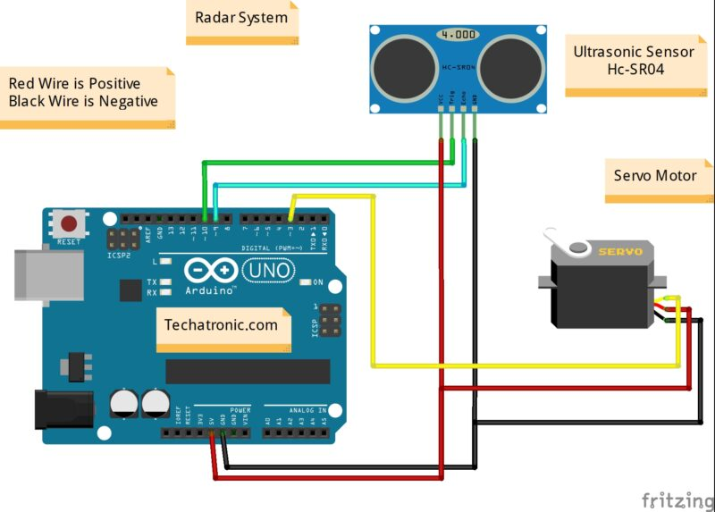
Fig – 5.1.1 Model Circuit

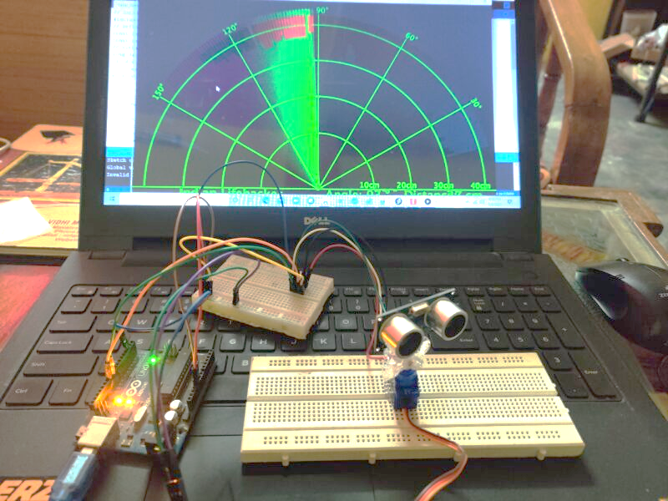
Fig – 5.1.2
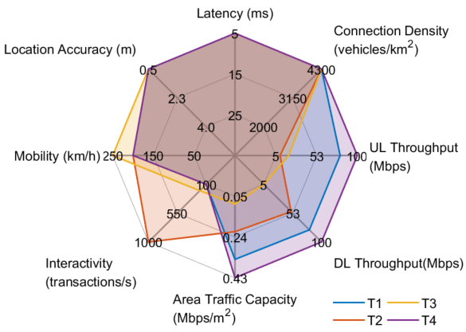
Fig 5.1.3

5.2 Task Flow

The development of a task flow will outline the step-by-step processes involved in the operation and interaction with the proposed solution. This task flow will provide a visual representation of how users will engage with the blind spot detection and avoidance system, from initial activation to receiving alerts and making informed decisions while driving.

The task flow will consider the user interface, input mechanisms, feedback mechanisms, and overall user experience. It will highlight the sequence of actions and interactions required for effective utilization of the system, ensuring a seamless and intuitive user experience.

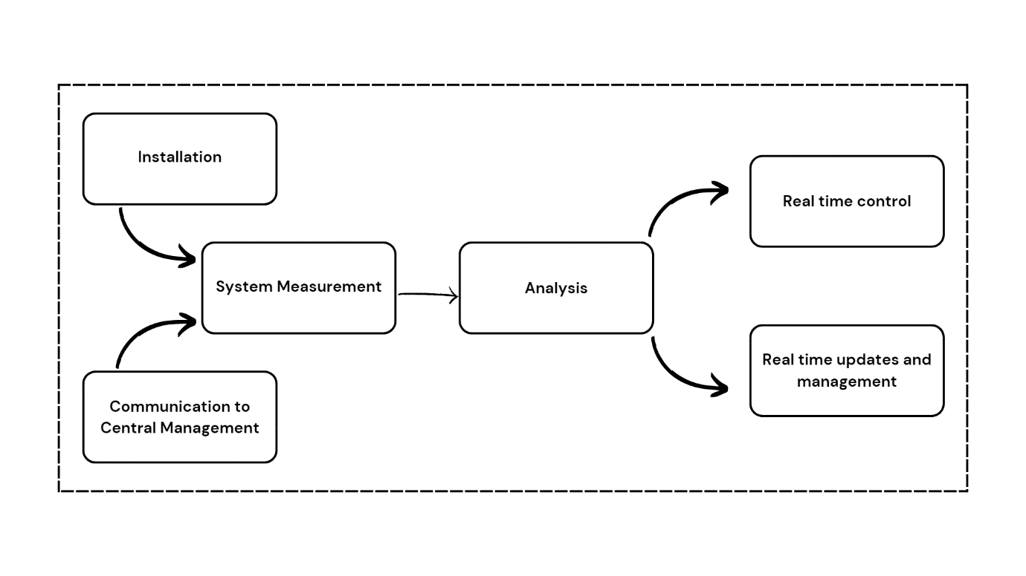
Fig – 5.2.1

5.3 Evaluation of Prototypes (Desirability, Feasibility and Viability)

The prototype circuit model will be evaluated based on the desirability, feasibility, and viability criteria to assess its potential for real-world implementation. These evaluations will consider factors such as:
- Desirability: The extent to which the prototype meets the needs and expectations of users. User feedback, surveys, and usability testing will be conducted to gauge user satisfaction and acceptance.
- Feasibility: The practicality and technical feasibility of implementing the prototype in real-world settings. Factors such as cost, complexity, scalability, and manufacturability will be considered.
- Viability: The commercial viability and market potential of the proposed solution. Market research, competitor analysis, and business modelling will be conducted to evaluate the solution's potential for adoption and sustainability.
Through the development, testing, and evaluation of the prototype circuit model, Chapter 5 aims to validate the effectiveness and feasibility of the proposed solution. This phase sets the stage for further refinement, optimization, and eventual integration of the solution into automotive safety systems.

CHAPTER 6
CONCLUSIONS AND FUTURE SCOPE

6.1 Conclusion
Presenting the conclusions drawn from the research, design, and development efforts. This chapter highlights the key findings and outcomes of the project, including:
- Recap of the problem statement: A brief overview of the problem statement related to blind spots in vehicles and the significance of addressing this issue.
- Summary of research: A concise summary of the research conducted, including the analysis of user needs, pain points, and existing solutions in the automotive safety domain.
- Solution overview: An overview of the proposed solution, emphasizing its potential to enhance automotive safety by mitigating blind spot challenges.
- Evaluation of the prototype: An assessment of the prototype's performance, usability, and feasibility based on user feedback, testing results, and predefined evaluation criteria.
- Impact and benefits: An exploration of the potential impact and benefits of implementing the proposed solution, such as improved safety, enhanced driver awareness, and reduced accident rates.

6.2 Future Scope

This section discusses potential avenues for future research, innovation, and implementation, including:
- Advanced sensor technologies: Exploring the integration of advanced sensor technologies, such as lidar or camera-based systems, to complement the miniature ultrasonic radar and further enhance blind spot detection capabilities.
- Artificial Intelligence (AI) integration: Investigating the incorporation of AI algorithms and machine learning techniques to improve the accuracy and efficiency of blind spot detection, enabling the system to adapt to various driving conditions and scenarios.
- Collaboration with automobile manufacturers: Collaborating with automotive industry stakeholders to incorporate the proposed solution into the design and production of new vehicle models, ensuring seamless integration and widespread adoption.
- Continuous user feedback and iteration: Establishing mechanisms for ongoing user feedback and iterative design improvements to address evolving user needs, technological advancements, and emerging safety standards.
- Regulatory considerations: Advocating for regulatory frameworks and guidelines that promote the adoption and standardization of blind spot detection and avoidance systems in vehicles, ensuring their effectiveness and safety.

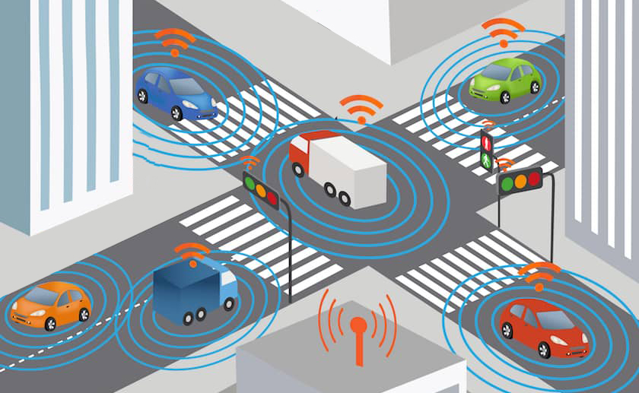
Fig – 6.2.1 V2V communication

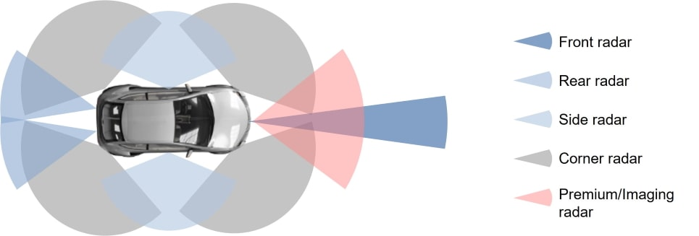

Fig – 6.2.2
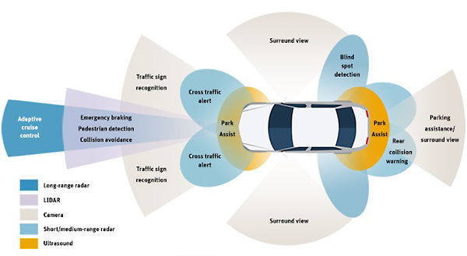
Fig – 6.2.3
References:
- Zhang, L., & Jin, Y. (2020). An Integrated Automotive Safety System Based on Ultrasonic Radar and Machine Vision. Proceedings of the IEEE 7th International Conference on Data Science and Advanced Analytics (DSAA), 306-313.
- Al-Falahi, M., & Kamarudin, M. R. (2020). A Review on Blind Spot Detection Systems for Automotive Safety. Journal of Advanced Research in Fluid Mechanics and Thermal Sciences, 71(2), 91-103.
- Balamurugan, G., & Ramasamy, M. (2019). Design and Development of a Smart Blind Spot Detection System for Automotive Safety. International Journal of Electrical and Computer Engineering, 9(6), 5174-5179.
- Huang, Y., Wang, X., Zhang, S., & Chen, Y. (2018). A Review of Automotive Radar: Challenges and Recent Advances. IEEE Transactions on Intelligent Transportation Systems, 19(12), 4000-4017.
- Salvo, P., Zanetti, S., & Fantuzzi, C. (2017). A New Approach for the Design of a Vehicle Ultrasonic Sensor Network. Sensors, 17(12), 2852.

APPENDIX A
USER SURVEYS

A.1 Questionnaire for User
We have took input from the Users through Google Forms. The link and QR Code are listed below along with the questionnaire:
- Have you ever witnessed a road accident?
https://forms.gle/3NKj39Y84MYWuBzYA
- What do you think is the reason behind accidents?
- What are the most essential requirements that must be addressed to effectively tackle the problem at hand?

- Do you think blind spots pose a risk of accidents on the road? If so, please provide your reasons.
- Do you think that the presence of automotive safety systems could have played a role in preventing accidents or reducing its severity?

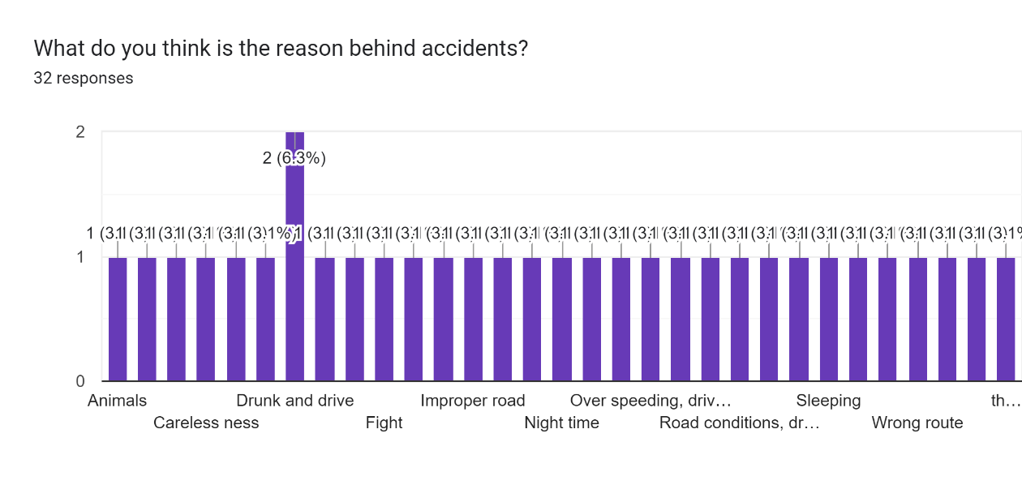
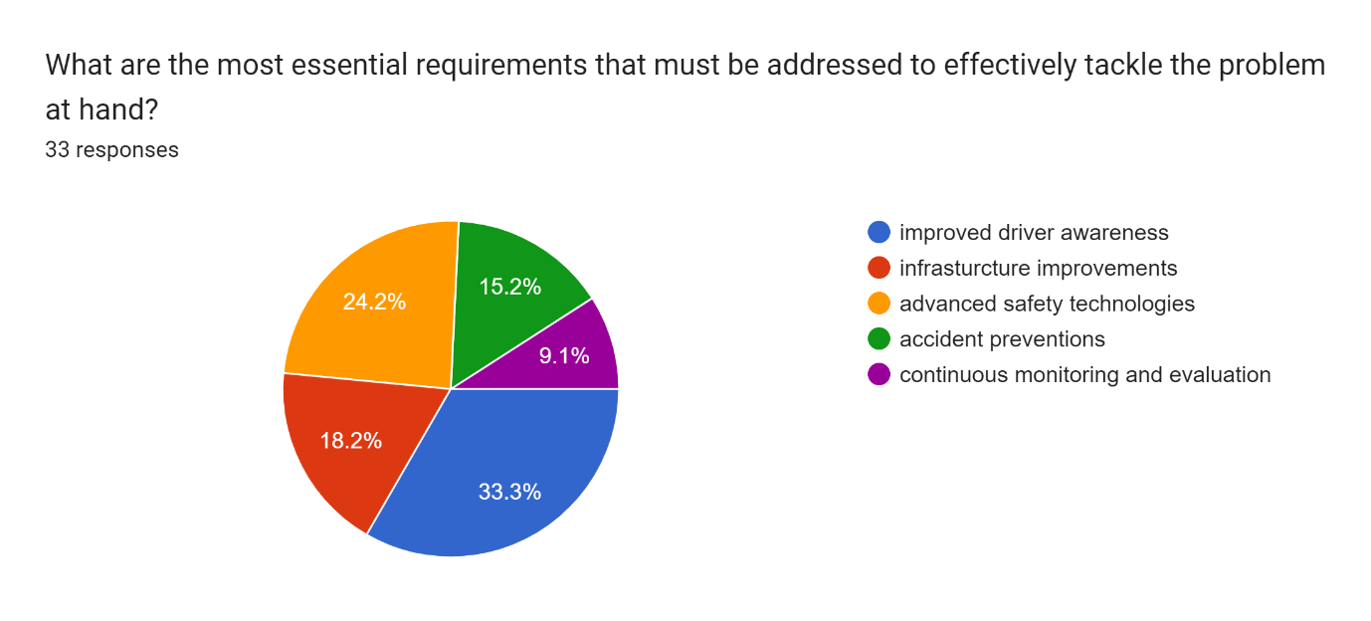
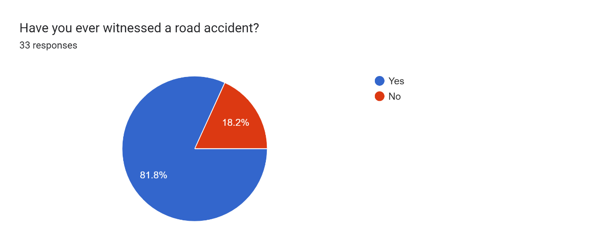
A.2 User Responses
Fig – A.2.3
Fig – A.2.2
Fig – A.2.1
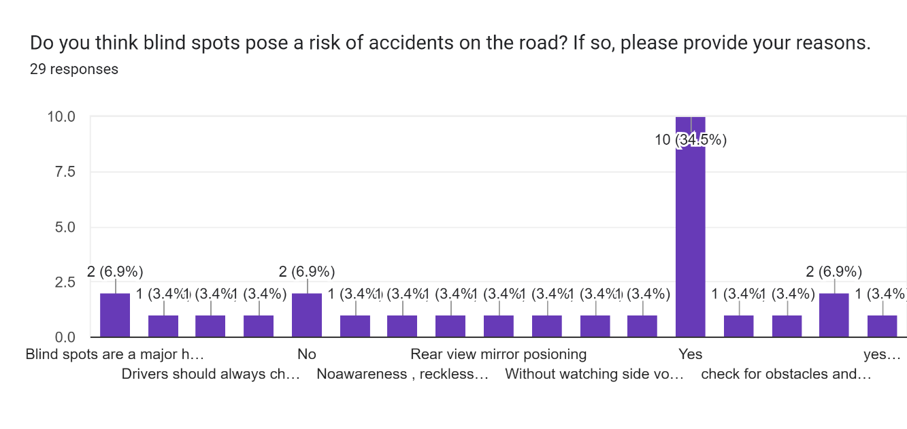
Fig – A.2.5
Fig – A.2.4
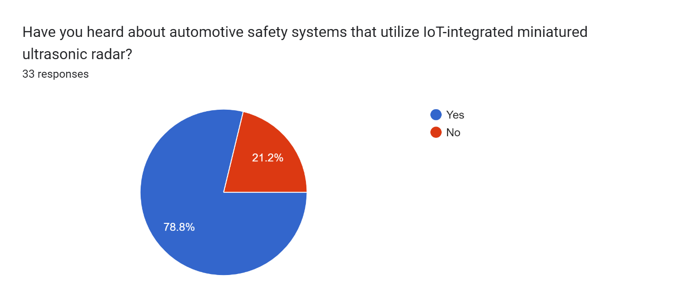
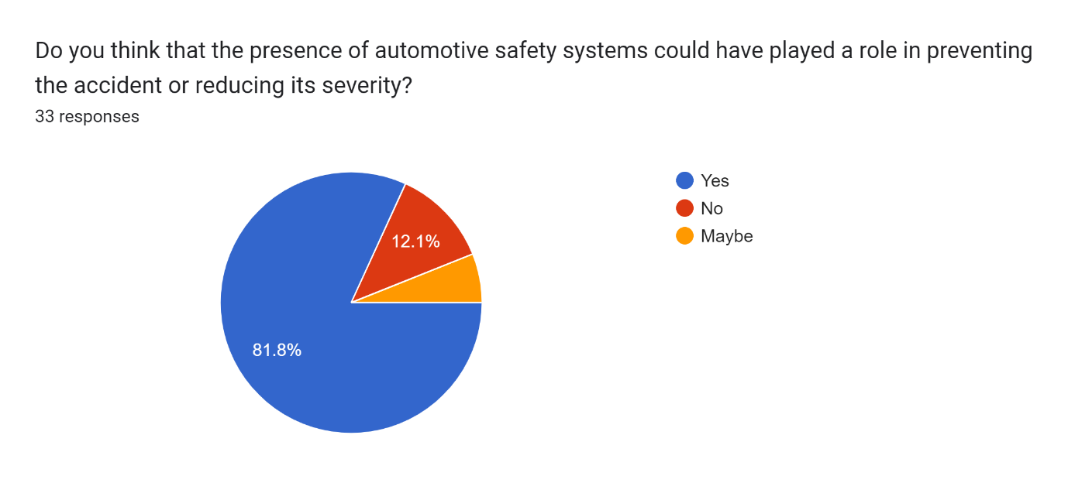
Fig – A.2.6

